08.03.2020



**MIDDLE EAST TECHNICAL UNIVERSITY**

DEPARTMENT OF ELECTRICAL AND ELECTRONICS ENGINEERING

**EE 568** Project #1

***Torque in a Variable Reluctance Machine***

GÖKHAN ÇAKAL – **2332120**

# Introduction

In this project, C cored oscillator is analyzed. The system is excited with a winding connected to the stator core as shown in Figure 1. The rotor structure has salient structure with no electrical excitation. Therefore, torque is resulted from the reluctance torque only.

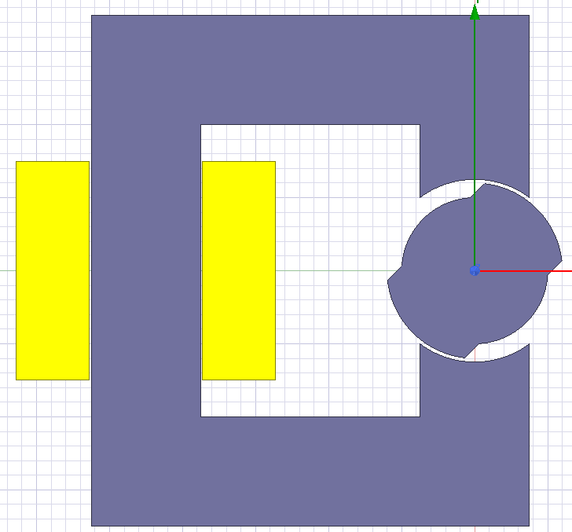

Figure 1: C-cored oscillator

The report is organized as follows: in the first part, analytical model of the oscillator will be derived using simplifications. The results will be compared with 2D finite element models in following parts. In the finite element analysis (FEA), Ansys Maxwell will be used. The effect of selecting linear and non-linear models will be observed. A control method will be proposed to get non-zero average torque. Also, animations that show the variation of the flux density in the system will be presented. Lastly, 3D models will be analyzed in FEA and observe the effects.

# Part I: Analytical Modeling

Analytical model of the oscillator starts with model definitions. In the analysis, zero position is defined at the position in which reluctance is zero as shown in Figure 2.



Figure 2: Definition of zero angular position

First, reluctance of the system should be derived. In the analysis, core is assumed to have infinitely permeability. Therefore, reluctance of the system is the reluctance of the air gap. In the rotor side, we have a salient pole structure. In order to make the system simpler, air gap reluctance is divided into two regions as shown in Figure 3, where and are air gap clearance of the regions, and are circumferential lengths of the regions. These definitions are used in reluctance calculation of the system. and are the angular positions of the regions. Note that first region has smaller air gap, thus smaller reluctance.



Figure 3: Air gap reluctance regions

In terms of , rotor position, and can be written as follows.

Note that for zero position, is zero. That is, all reluctance of the system is the reluctance of the region one. As the increases, the reluctance of the second region gets into the stage and equivalent reluctance of two regions become inductance of the system. and arc lengths can be written as

where is the mean radius of the system. Then, reluctance of the two regions can be written as

where and are the flux passing areas of the two systems. They can be written as

where is the model depth. Then, equivalent reluctance of the system is simply combination of two reluctances.

Then, inductance of the system can be found as follows

where is the number of turns in the system. In order to verify our analytical results, finite element analysis is conducted and results are shown in Figure 4. Compared to FEA, it is seen that analytical results are slightly smaller. This is due to the assumption that flux is passing through only defined two regions. That is, fringing and leakage fluxes are ignored. However, in FEA, these flux paths also exist and effective reluctance is smaller. This results in higher inductance for FEA.



Figure 4: Inductance comparison

As a next step in analytical modeling, stored energy and torque is obtained. It is known that there is no second electrical excitation on the system. Therefore, stored energy is due to the winding on the stator core only and it is expressed as

where is the current applied to the windings. From the stored energy, torque can be easily obtained as follows

In order to see the accuracy of the analysis, FEA results are compared with analytical calculations of the torque and the results shown in Figure 5 is obtained. Again, due to the assumptions in analytical model, torque has discontinuity. However, in the FEA, due to fringing and leakage fluxes, actual torque curve with respect to position has smoother transition.



Figure 5:Torque comparison

In order to increase the accuracy of the analysis, various approaches can be applied. Firstly, in our analytical model, reluctance is calculated only in two regions. However, fringing and leakage fluxes may be added to the model. Also, there is a small region between two regions. When is non-zero, this region has varying air gap clearance. Therefore, when this is added to our model, the results become more accurate. Secondly, the core is assumed to be infinitely permeable. However, when the saturation effects also added to the system, the results become more accurate.

# Part II: FEA Modeling (2D – Linear Materials)

In this part, the model is simulated using Ansys Maxwell 2D solution. As a core material, steel1010 is used with constant relative permeability of 906. Flux density vectors for various angles are plotted below.

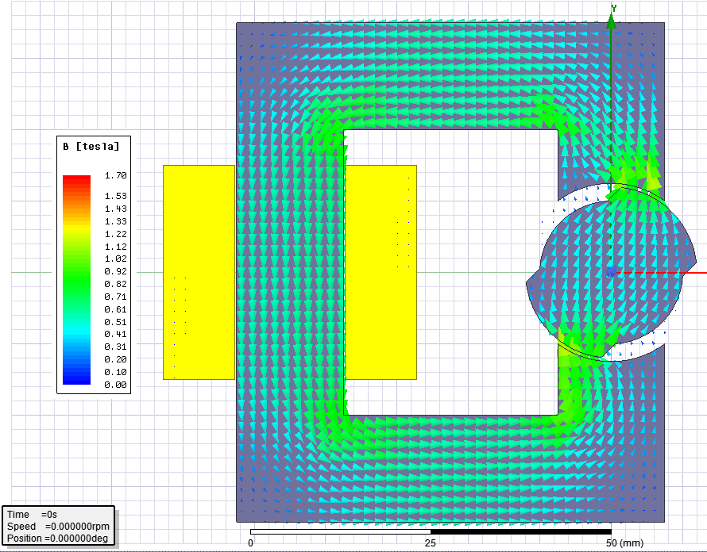

Figure 6: Flux density vector for linear material at -45 deg position

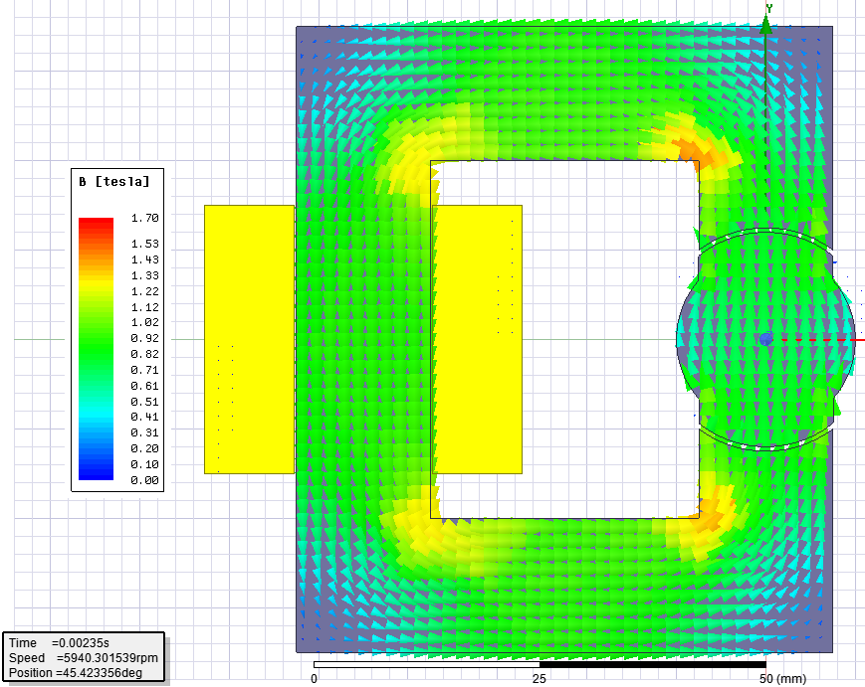

Figure 7: Flux density vector for linear material at 0 deg position

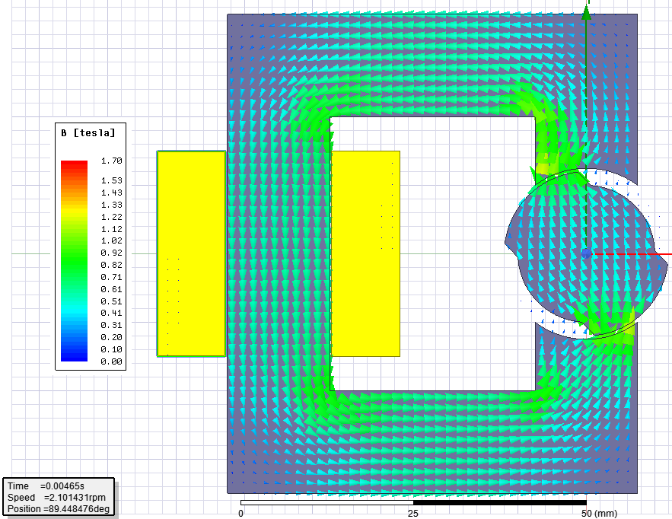

Figure 8: Flux density vector for linear material at -45 deg position

Here, we see that for zero angle position, reluctance is minimum and inductance is maximum. Flux density in the core at different positions show the reluctance change. At minimum reluctance position, the flux density in the core is highest and the core is tending to be saturated. However, since we used linear material with constant permeability, this is not the case.

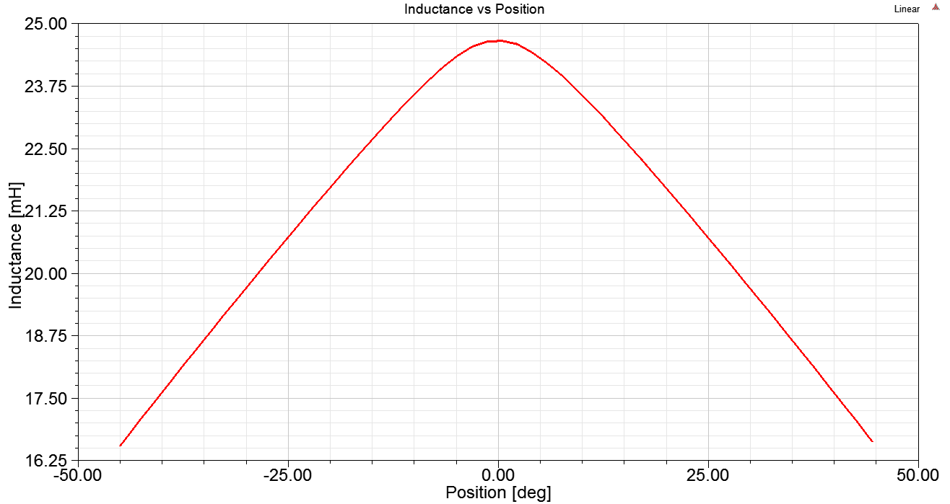

Figure 9: Inductance vs position for linear material

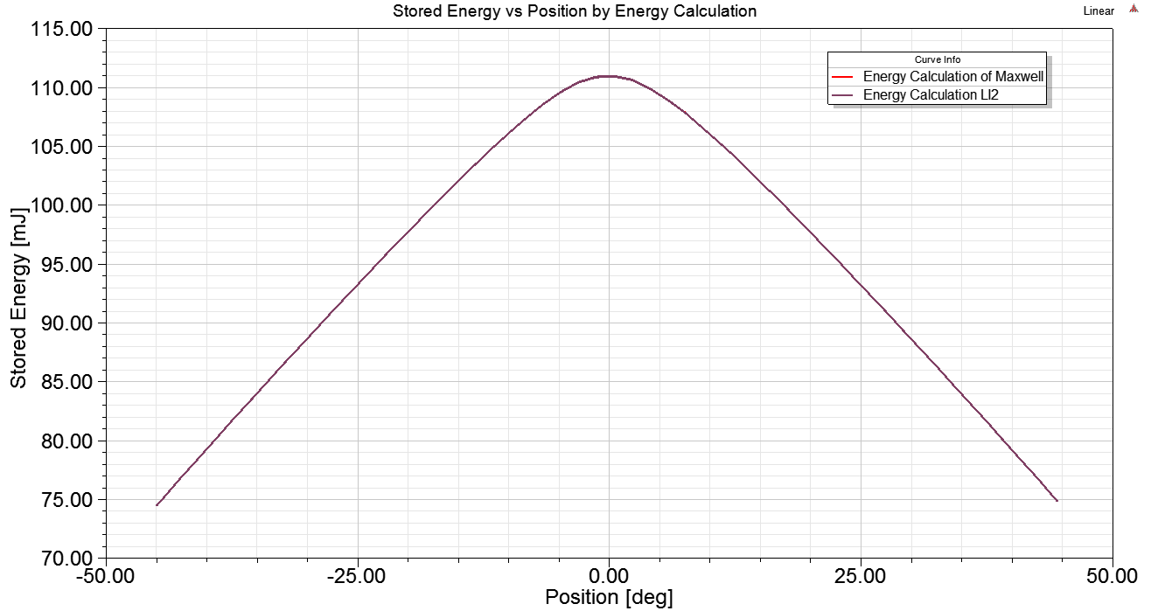

Figure 10: Stored energy for linear material

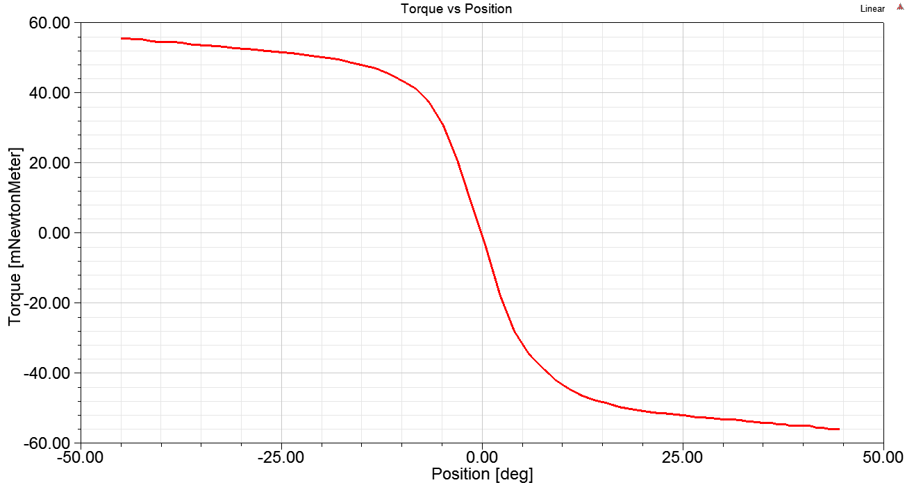

Figure 11: Torque for linear material

Here, the variation of inductance, stored energy and torque are shown. Since we have DC excitation, stored energy is directly proportional with the inductance as shown. Torque is simply position derivative of the stored energy. In that extend, torque is positive with negative angle positions. At zero position, torque is also zero and as rotor angle increases in positive side, negative torque occurs as shown in the figure above. Comparison with analytical model is presented in previous section.

# Part III: FEA Modeling (2D – Nonlinear Materials)

In this part, I used core material of steel1010 with BH curve defined. The core may saturate at high currents. The BH curve of the material used is given in appendices section at the end of this report. Below, again variation of flux density vectors is shown with different positions.

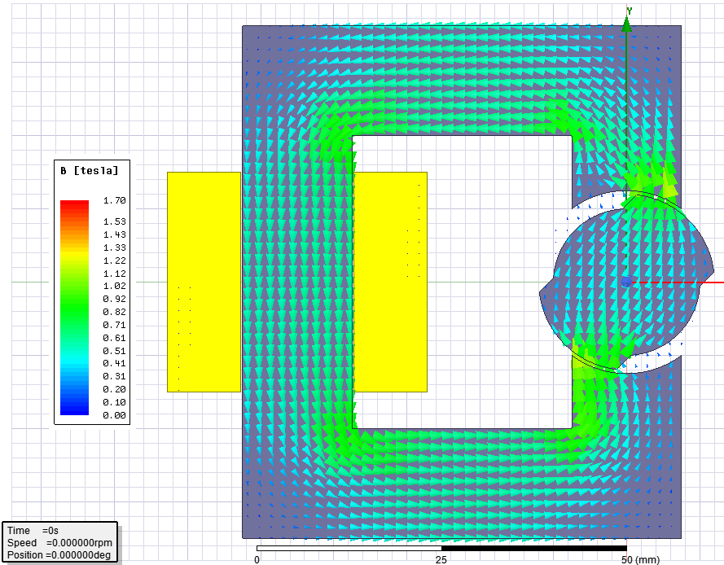

Figure 12:Flux density vector for non-linear material at -45 deg position

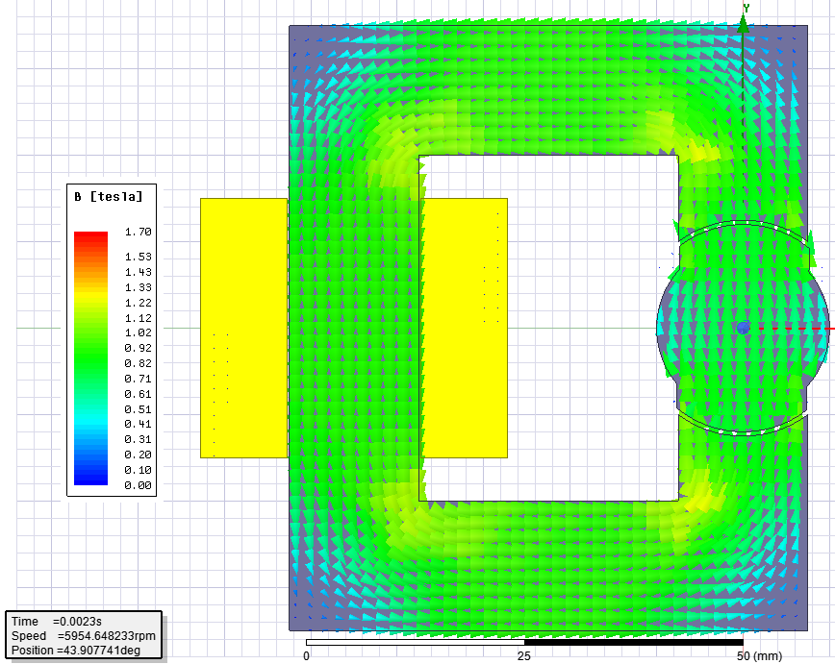

Figure 13:Flux density vector for non-linear material at 0 deg position

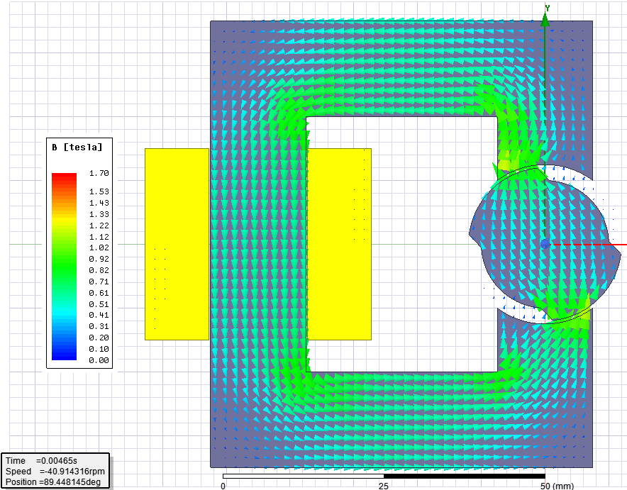

Figure 14:Flux density vector for non-linear material at 45 deg position

We can see the variation of flux vectors at different positions. There is not much difference with linear material. This is due to small applied current. At 3A, the core is not saturated and it acts like a linear material.

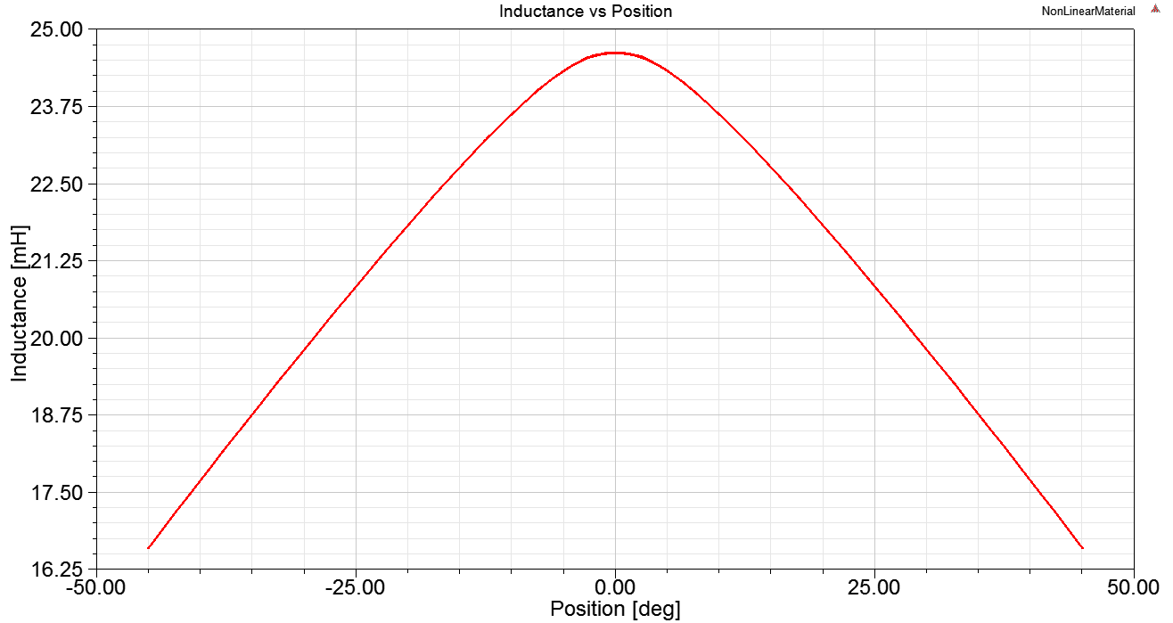

Figure 15: Inductance vs position for non-linear material

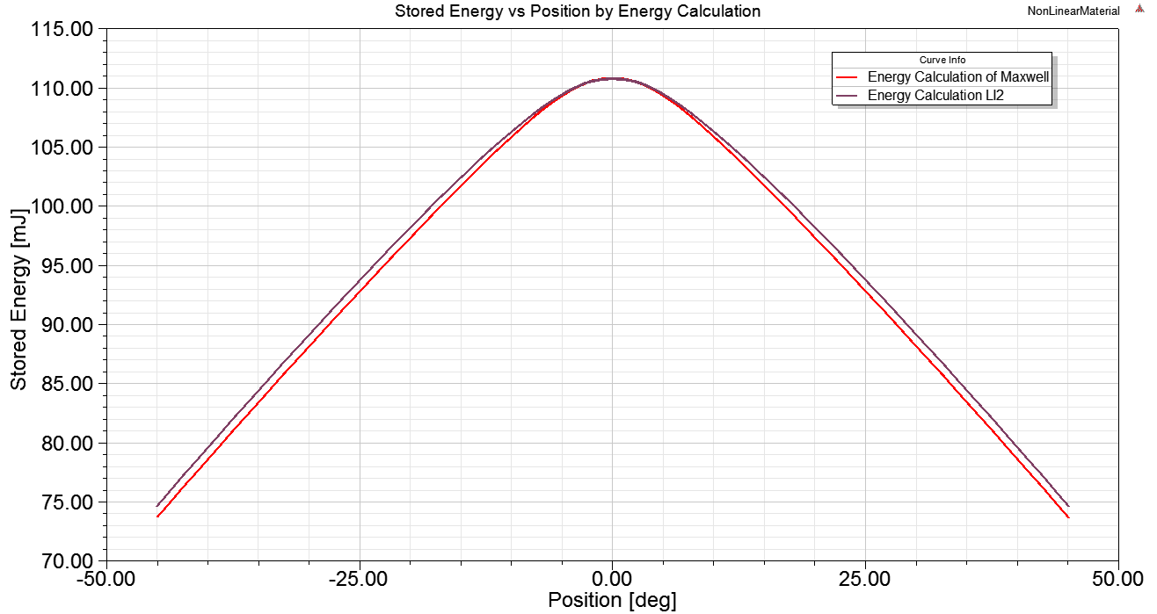

Figure 16: Stored energy for non-linear material

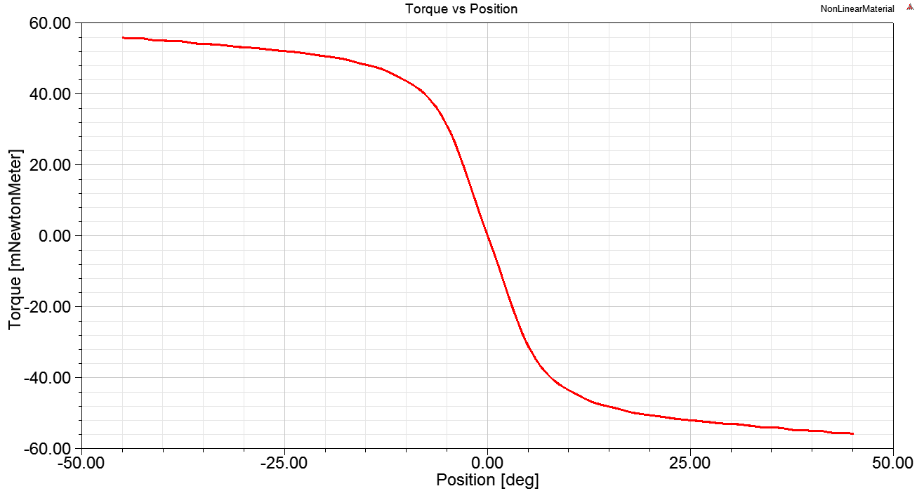

Figure 17: Torque for non-linear material

The results are quite similar with linear part. This shows that our core is not saturated at this current rating and our core behaves like a linear core. In order to see a saturated core, I increased current to 100 A and obtain the inductance variation shown in Figure 18. Compared to non-saturated case in Figure 9 and Figure 15, inductance of the saturated core decreased around 65% due to increased reluctance.

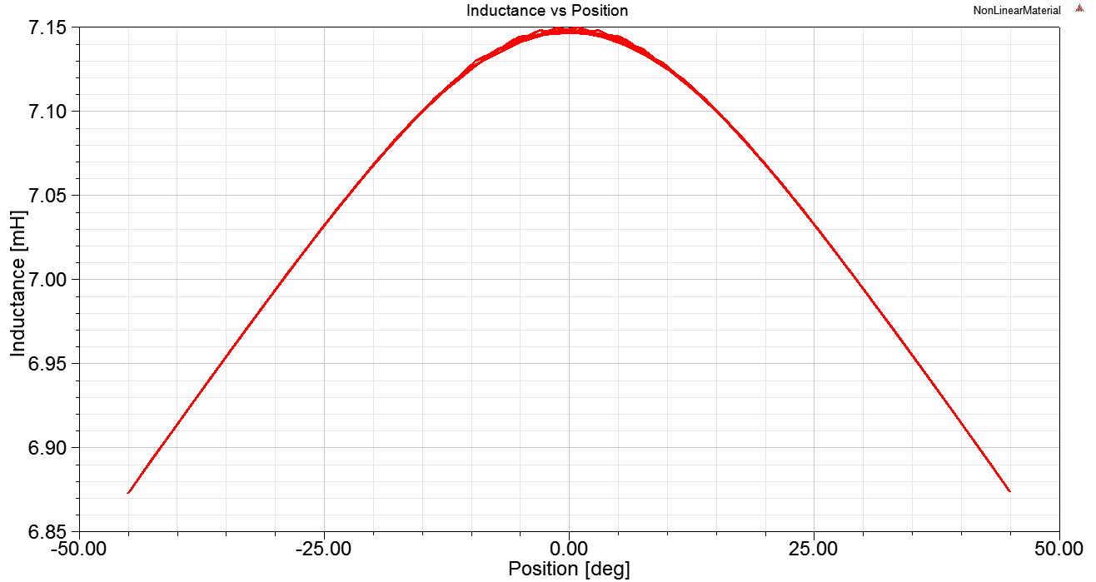

Figure 18: Saturated core with 30A excitation

# Part IV: Control Method

In order to have non-zero average torque and full rotation, various excitations can be applied to the windings instead of constant DC current. In my case, I preferred to apply the square shaped waveform as shown in Figure 19. Note that, in this excitation, for a time period, positive current is applied and the rotor is rotated. Then current is cut for a time. With the inertia of the system, the rotor continues to rotate. Then, DC current is applied again to continue rotation. With this type of periodic excitation signal, non-zero average torque or full rotation is achieved.

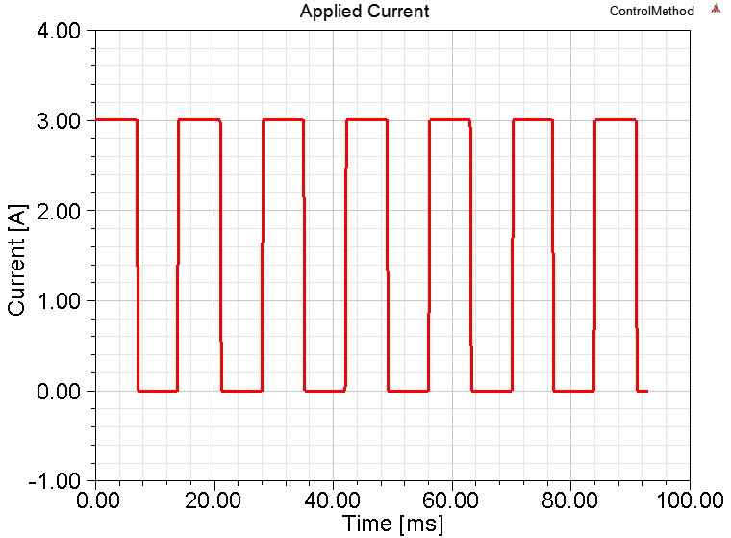

Figure 19: Applied current for full rotation

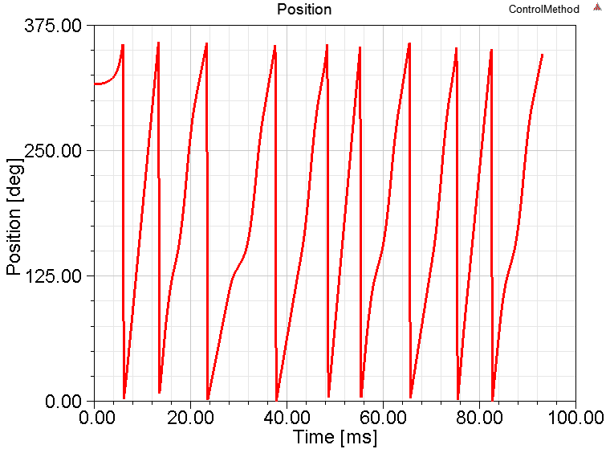

Figure 20: Full rotation

# Part V: Bonuses

All bonuses are uploaded to the project repository.

# Part VI: 3D FEM Analysis

In this part, model is created in Maxwell 3D solver as shown.

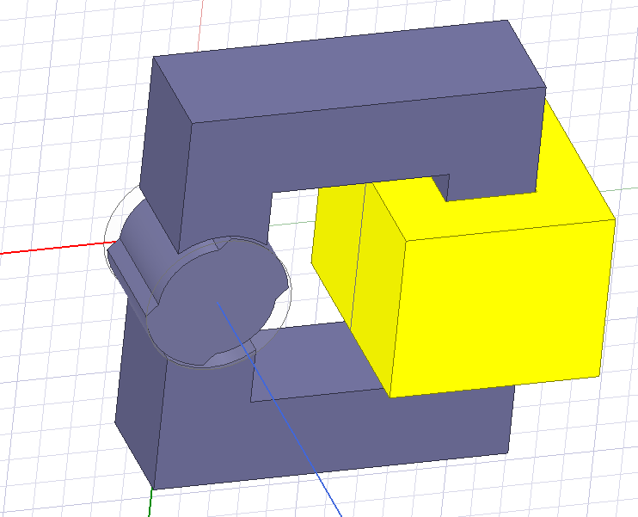

Figure 21: 3D Model

Inductances are compared in Figure 22. Due to leakage and fringing effects, it is shown that 3D solution has more inductance compared to 2D solutions. This is due to end winding effect of the design, which is not modeled in 2D model and due to fringing effects. 3D results give more realistic solutions.

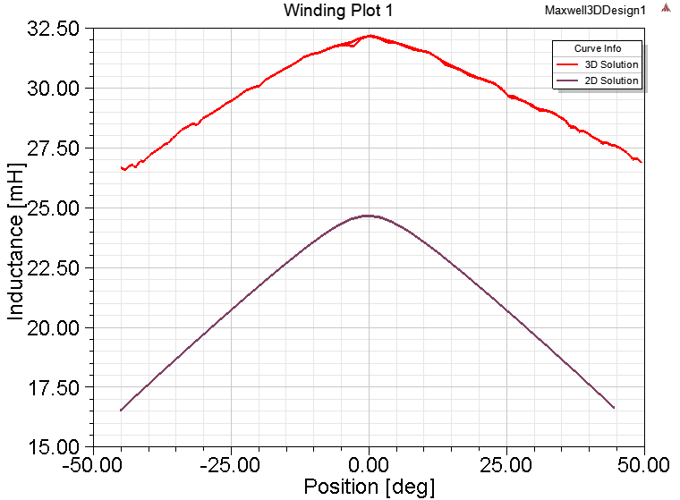

Figure 22: Inductance comparison

# Appendices: Material Characteristics and Matlab Script

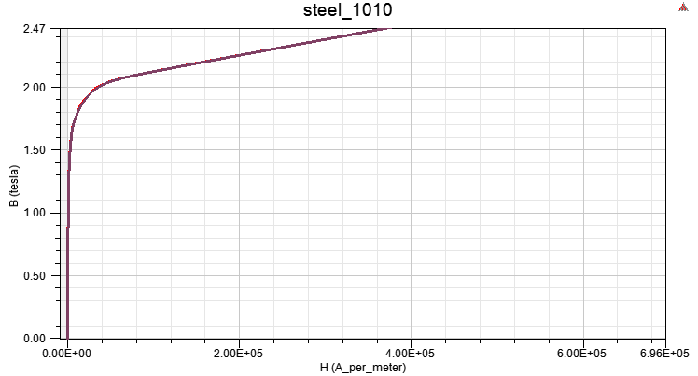

Figure 23: BH curve of the non-linear material used

%This script is for analytical modeling of oscillator model

clc; clear all; close all;

thet = linspace(-45,45,5000); %deg, electrical angle

g1 = 2*0.5e-3; %m, air gap clearance of the first part

g2 = 2*2.5e-3; %m, air gap clearance of the second part

d = 20e-3; %m, model depth

mu0 = pi*4e-7; %H/m, permeability of free space

I = 3; %A, current

N = 250; %number of turns

rad_ef = 11e-3; %m, effective radius

thet1 = 80-abs(thet); %deg, angle of the first part

thet2 = abs(thet); %deg, angle of the second part

len1 = pi*rad_ef*thet1/180; %m, arc length of first part

len2 = pi*rad_ef*thet2/180; %m, arc length of second part

area1 = len1*d; %m2, area of the first part

area2 = len2*d; %m2, area of the second part

rel1 = g1/mu0./area1; %1/H, reluctance of first part

rel2 = g2/mu0./area2; %1/H, reluctance of second part

rel = rel1.*rel2 ./ (rel1+rel2); %1/H, effective reluctance

ind = N^2./rel; %H, inductance

energy = 0.5*ind*I^2; %J, stored energy

torque = diff(energy)./diff(thet*pi/180); %Nm, torque

## inductance plot

filedir = 'C:\Users\DELL\Documents\Dersler\EE568 Selected Topics on Electrical Machines\Project 1\Ind.csv'; % file import

ind_fem_data = readtable(filedir,'HeaderLines',1);

thet_fem = table2array(ind_fem_data(:,2)); %ms, time data

ind_fem = table2array(ind_fem_data(:,3)); %V, induced voltage fem phase

plot(thet_fem,ind_fem,thet,ind*1e3,'linewidth',2);

legend('FEA','Analytical');

xlabel('Angular position (deg)');

ylabel('Inductance (mH)');

title('Inductance comparison');

## torque plot

filedir = 'C:\Users\DELL\Documents\Dersler\EE568 Selected Topics on Electrical Machines\Project 1\Tor.csv'; % file import

torque_fem_data = readtable(filedir,'HeaderLines',1);

thet_fem = table2array(torque_fem_data(:,2)); %ms, time data

torque_fem = table2array(torque_fem_data(:,3)); %V, induced voltage fem phase

plot(thet_fem,torque_fem,thet(2:end),torque*1e3,'linewidth',2);

legend('FEA','Analytical');

xlabel('Angular position (deg)');

ylabel('Torque (mNm)');

title('Torque comparison');

[*Published with MATLAB® R2016a*](http://www.mathworks.com/products/matlab/)